Proposed Draft – Treatment of Investment Partnership Income (Edits and Comments)
For Discussion Purposes Only
August 18, 2022
Substantive edits added after the July 25, 2022 work group call are highlighted in yellow.
GENERAL NOTES IMPORTANT TO REVIEW OF THE MODEL
(This section was modified to respond to certain comments and questions received.)
- Support for this mode is found in a detailed white paper available on the MTC project webpage here: https://www.mtc.gov/Uniformity/Project-Teams/Partnership-Tax
- Edits to the original are shown (in Blue) and notes (in Red). For ease of review, notes included relate to the most recent edits and notes explaining previous edits have been deleted but can be found in earlier drafts on the project web page, here: https://www.mtc.gov/Uniformity/Project-Teams/Partnership-Tax.
- This draft is still being reviewed and does not incorporate all the changes suggested.
Basis for the Model
It is an essential principle of federal pass-through taxation that taxable owners of pass-through entities treat items of income, expense, gain, and loss as if they had earned or incurred the same items directly from the same source and activities as the pass-through entity itself. (See IRC §702(b) for partnerships and IRC §1366(b) for Subchapter S entities). This principle also applies to items flowing through multi-tiered entities—the character of an item is retained as it flows through. This prevents pass-through structures from being used to change the tax character of items and undermine the federal substantive tax rules.
Similarly, when sourcing pass-through items for non-corporate partners, states generally look to the nature and location of the activities of the partnership. This sourcing information then flows through to the partners. Like the federal principle, this prevents pass-through structures from being used to shift income sourcing and undermining state taxation.
Application of these federal and state principles as generally described here will sometime result in sourcing certain partnership items not to the state where the partnership has activities or operations, but to the partner’s state of residence. This is because if the same items were earned or incurred by the partner directly from the same activities, they would ordinarily be sourced to the partner’s residence.
But just because a partnership has investment income does not mean that income would be sourced to a partner’s residence. Instead, proper sourcing depends upon the true nature and character of income, which in turn depends on the activities of the partnership, the nature of the investments, and the partner’s own relationship to the partnership.
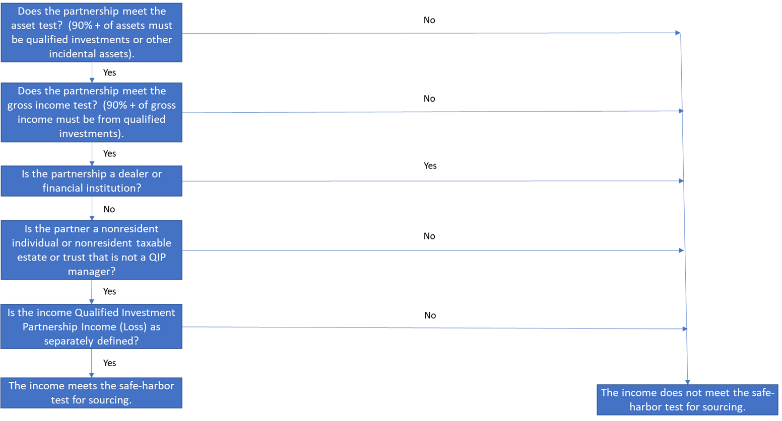
The model creates a safe-harbor allowing certain nonresident partners to exclude qualifying investment partnership income even if the partnership conducts activities in the state. It also provides a means for partnerships to certify that they meet the requirements as a Qualified Investment Partnership. The model draws on similar rules adopted by several states. It does not provide an exhaustive test for when partnership income of nonresidents might be sourced to residence. To achieve its purpose and avoid abuse, the model imposes three separate sets of requirements: (1) on the partnership, (2) on the partner, and (3) on the investments. All three must be met as the graphic below generally depicts.
Also note:
- The safe harbor applies only to income tax on individuals and taxable estates and trusts – not corporations. Corporations have sufficient guidance for sourcing their income, including investment income.
- The model’s definitions contain the applicable requirements and so may act to create certain exceptions to residency-sourcing.
- This version of the model would allow but not require certification, but would require all partnerships asserting that they are qualified investment partnerships to state that on their tax return and to disclose certain information.
There have been questions about whether this is a draft statute or regulation. It is drafted as a statute but states might also adopt it as a regulation.

MODEL
Title. Treatment of Certain Income of Nonresident Qualifying Investment Partnership Partners. Section 1. Purpose: [Drafter’s note: This section is included to give guidance to the use of anti-abuse authority in Section 4 below.]  The purpose of this [Act] is to create a safe harbor for sourcing and taxation which is consistent with applicable state sourcing requirements of certain investment income, and to clarify that whether income is derived from the holding of those investments directly or from an interest in a qualified investment partnership that holds those investments, the sourcing will be the same. The purpose of this [Act/Section/Rule] is to provide a safe harbor for the sourcing of investment income or loss by certain nonresident partners where that income or loss would have been sourced to the nonresident partner’s state of residency had the partner directly engaged in the activities of the entity that generated the income or loss. In cases where the requirements of this [Act/Section/Rule] are met, [the State] agrees that the income or loss is properly sourced to the nonresident partner’s state of residence under [reference to general state tax and sourcing statutes]. | NOTES here relate to important edits made after July 25, 2022 which are highlighted in yellow at left.  There have been numerous comments and questions on this purpose section. This re-write is to make clear that the purpose is to create a safe-harbor applicable to the sourcing of certain investment income that is consistent with state law generally. Also see the anti-abuse rules in Section 4 below which have also been re-written.
Section 2. Definitions:  (a) In this [Act]:  (1) “Amount of Gross Income or Proceeds” refers to the total of all items of gross income or proceeds from activities or sales of any kind.  (2) “Dealer in Qualifying Investments” is any person who meets the definition of a "dealer” in 26 U.S.C. § 475(c) with respect to Qualifying Investments or who regularly purchases Qualifying Investments for sale to customers in the ordinary course of a trade or business or regularly offers to enter into, assume, offset, assign or otherwise terminate positions in Qualifying Investments with customers in the ordinary course of a trade or business;  (3) “QIP Manager” means any individual partner that holds an ownership interest in a Qualified Investment Partnership that was acquired in exchange for performing the management of the Partnership including recruiting investors, overseeing investments, performing administrative functions, and similar activities.  (4) “Nonresident QIP Partner” means a person subject to tax under [reference to state income tax law] that holds an ownership interest in a Qualified Investment Partnership and is neither a Dealer in Qualifying Investments nor a QIP Manager at any time during the tax period, provided the person is:  (A) an individual who is a nonresident as determined under [reference to applicable state law];  (B) an estate that is a nonresident as determined under [reference to applicable state law]; or  (C) a trust that is a nonresident as determined under [reference to applicable state law].  [Drafter’s Note: States should confirm that the general treatment of taxable estates and trusts and the sourcing of their income would be compatible with the purpose of this safe harbor.]  (5) “Partnership,” as the term is used, alone or in conjunction with other terms, means an entity properly subject to treatment as a partnership under Subchapter K of the Internal Revenue Code.  (6) “Other Pass-Through Entity” means an entity, other than a Partnership, whose income is taxed to its interest holders and includes corporations properly taxed under Subchapter S of the Internal Revenue Code and certain taxable trusts. | The term “partner” was substituted in this definition for “individual” recognizing recent changes to include taxable estates and trusts.  This definition of other pass-through entity will be used in limiting the definition of “qualified investments” below, as further discussed in sections below.
(7) “Qualified Investment Partnership” means a Partnership that meets all the following requirements for the applicable tax period:  (A) No less than 90 percent of the cost of the Partnership’s total assets consists of Qualified Investments and the office facilities and tangible personal property reasonably necessary to carry on its investment activities;  (B) No less than 90 percent of the Partnership’s Amount of Gross Income or Proceeds is derived from items that would be characterized as giving rise to Qualified Investment Partnership Income (Loss), as determined at the level of the partnership which first recognizes the items;  (B) No less than 90 percent of the Partnership’s Amount of Gross Income or Proceeds recognized in the tax year are items that give rise to Qualified Investment Partnership Income (Loss). For purposes of this test, only gross income or proceeds recognized by the Partnership are included in the calculation of the percentage; (C) The Partnership is not a Dealer in Qualifying Investments at any time during the tax period; and  (D) The Partnership is not a financial institution as defined in [reference to applicable state law].  (E) The partnership has certified to the [state revenue agency] that it meets the criteria above with respect to the tax period covered by the certification, in a form and at a time prescribed by the [state revenue agency].  (7) “Qualified Investment Partnership Income (Loss)” means interest, dividends, distributions, or gains and losses from Qualified Investments, including distributive share from lower-tier Qualified Investment Partnerships. For purposes of this definition, distributive share of items from lower-tier Qualified Investment Partnerships retain their characterization as either items that meet the requirements for Qualified Investment Partnership Income (Loss), or not, as the items pass through any upper tier partnerships.  (8) “Qualified Investment Partnership Income (Loss) means items of income, expense, gain, or loss that are derived from Qualified Investments, including interest, dividends, or gains or losses from exchange of those Qualified Investments. Whether the items meet the requirements of this definition is determined when those items are first recognized by a Partnership or Other Pass-Through Entity regardless of whether those items then flow through other Partnerships or Other Pass-Through Entities. | There have been questions about this gross income test. Because it uses gross income or proceeds, as defined, there is no problem computing the percentage in cases involving losses. Also note that income (loss) that does not separately qualify as Qualified Investment Partnership Income (Loss), including items passed through from lower-tier entities, is not subject to the safe-harbor sourcing rule. See Section 3. This percentage test is only meant to determine whether the partnership is primarily engaged in qualified investment activity.  There have been continuing questions about the effect of a partnership’s failing to certify for minor issues as well as whether the requirements might be waived if the tax agency determines income would still be sourced to residence. Edits in this draft address these issues by removing the requirement for certification here in the definition and providing a separate revisions to the definition of Qualifying Investments and providing new provisions concerning reporting and certification highlighted below.  This further clarifies that the determination of whether something meets the requirements is made when the item is first recognized.
(9) “Qualified Investments” means:  (A) Common stock of corporations, including preferred or debt securities convertible into common stock; and preferred stock, including debt securities convertible into preferred stock, provided that the corporation is taxed under the Internal Revenue Code Subchapter C;  (B) Bonds, debentures, and other debt securities such as certificates of deposit and collateralized securities;  (C) Deposits and any other obligations of banks and other financial institutions regulated by the United States government, a state, or by any political subdivision or governmental agency thereof, and cash and cash equivalents, including foreign currencies;  (D) Corporate stock and bond index securities, future contracts, derivative securities, warrants or options on securities, and other similar financial securities and instruments;  (E) Interest in a Partnership or Other Pass-Through Entity but only if that Partnership or Other Pass-Through Entity would meet the requirements to be a Qualified Investment Partnership under Section 2(a)(3) above;  (F) Other similar or related financial or investments contracts, instruments, or securities.  The term does not include:  (G) Any investment in a captive REIT, as defined by [reference to federal or state law]; or  (H) Loans that are not debt securities.  (b) All other terms used in this Section are given their general meaning as used under the [reference to personal income tax act]. | The changes in Subsection (9)(A) and (E) here relate to comments and concerns we received with respect to the requirement in Section 3(b) below. That section would have excluded from the treatment of qualified investment income any income from investments in which the partner had been significantly involved or had held a significant ownership share. Because of other limitations in the definitions, that exclusion would have primarily affected income or loss from holdings in S corporations and perhaps some other pass-through entities.  So, as an alternative to that exclusion, the definition of qualified investments has been modified here. This alternative approach has the added advantage that it would treat holdings in other pass-through entities the same as holdings in other partnerships—that is—it requires that the entities meet requirements for QIPs in order for the upper-tier partnership to meet the requirements itself.

Section 3. Certain Qualified Investment Partnership Income of Nonresident QIP Partners Excluded from Personal Income Tax.  A Nonresident QIP Partner may exclude from tax under [reference to state income tax] the partner’s distributive share of Qualified Investment Partnership Income (Loss).  ( | We have received comments that this provision goes too far or is vague. As a simpler alternative to this provision, we have proposed a modification to the definition of Qualified Investments, above.
Section 4. Authority Delegated to the [State Revenue Agency].
(a) The [state revenue agency] has authority to issue regulations and other guidance to carry out the purpose of this [Act] including, [but not limited to]:
(1) Requirements for the certification of Qualified Investment Partnerships;
(2) Requirements for tax and information returns to be filed or provided by Qualified Investment Partnerships including requirements to provide lists of partner names and addresses, lists of investments or other investment information, lists of other assets and their values, and similar records.
(3) Rules for the calculation of asset and income values for purposes of implementing the requirements of this [Act];
(4) Filing of withholding or estimated payments [and/or composite returns] by Qualified Investment Partnerships when any income of such Partnerships is subject to tax in this state and as provided by this Section and [reference to state law] waiver of requirements and related penalties in cases where a previously qualifying Partnership fails to qualify.
(b) A Partnership must state on its tax return whether it asserts that it meets the requirements to be treated as a Qualified Investment Partnership for the tax period. It must also provide information to its partners sufficient so that they can determine the proper amount of any Partnership items of income, expense, gain, or loss that are not Qualified Partnership Investment Income (Loss), as well as any other information determined by the [state revenue agency] to allow proper reporting of income or loss that would be taxable in the state.  (c) Upon a properly completed and timely filed application, as directed by the [state revenue agency], the [state revenue agency] may certify that a Partnership meets the requirements to be treated as a “Qualified Investment Partnership” for a particular tax period. In granting this certification, the [state revenue agency] has discretion to waive one or more of the requirements for a particular tax period for a Partnership that might fail to meet the qualification, provided that the Partnership demonstrates that this failure would not alter the treatment of the Qualified Investment Partnership Income (Loss) by Nonresident QIP Partners under [reference to applicable state income tax provisions], and such qualifying income (loss) can be properly determined. | There were a number of questions and comments about the requirements of this Section 4 and about the requirement that partnerships certify that they qualify under the requirements. This provision and the one below in Subsection (c) are meant to provide a viable alternative to mandatory certification.  This provision would make certification elective rather than mandatory.
 | There have been a number of comments and questions about this provision. Provided that other edits suggested in this version as well as the provisions in Section 4(a) above are adopted, it would appear this provision may be unnecessary.

